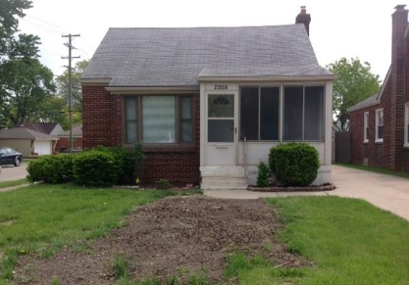
22858 David Avenue
Eastpointe, MI 48021

3BR – 1 BA – 950SF
Price: $88,900
Rent $875

Taxes $1,755
22858 David Avenue, Eastpointe, MI 48021

Property ID SPI954360

Click Link below for a HouseCanary Property Explorer Report :

https://pexp.housecanary.com/shared-report/22858-david-ave/eastpointe/MI/48021/ZdLxqwMNONRrP

Click Link below for an RealtyTrac Asset Report
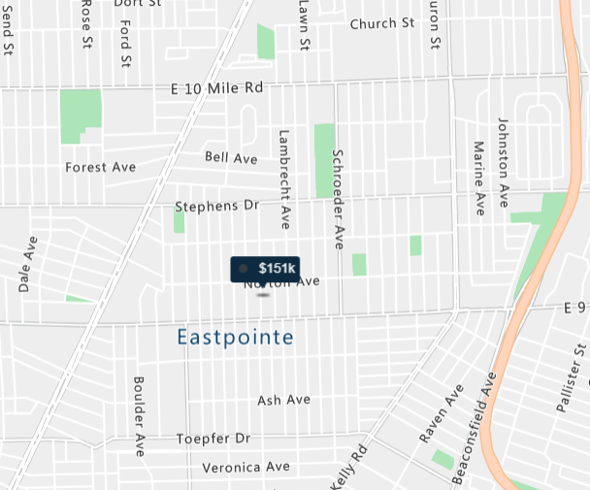
https://www.realtytrac.com/homes/mi/eastpointe/48021/22858-david-ave-49875479/?preForeclosure=true&auction=true&bankOwned=true&notInForeclosure=false&notYetListed=true&listedForSale=false&recentlySold=false&listedOnlineAuction=true

For more information about the asset contact Marketing@REI-ReferralNetwork.com or call 207-443-3314

