19905 Rosedale
St Clair Shores, MI 48080

3BR – 1 BA – 899SF
Price: $148,900
Rent $950

Taxes $1,707
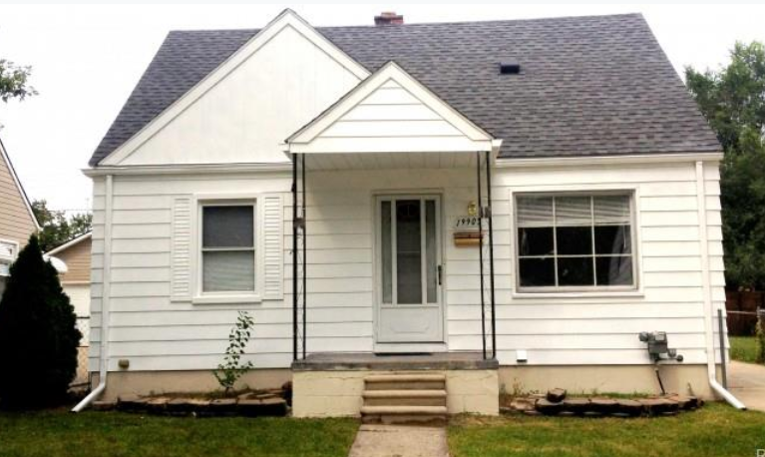
19905 Rosedale St, Saint Clair Shores, MI 48080

Property ID SPI5951022

Click Link below for a HouseCanary Property Explorer Report :

https://pexp.housecanary.com/shared-report/19905-rosedale-st/saint-clair-shores/MI/48080/r2Eje5BZNzYMw

Click Link below for an RealtyTrac Asset Report
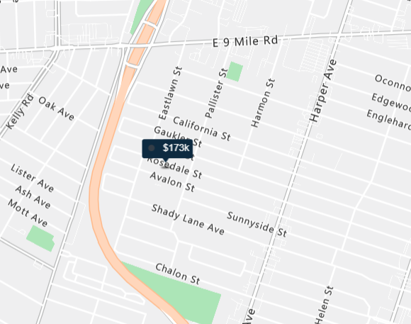
https://www.realtytrac.com/homes/mi/saint-clair-shores/48080/19905-rosedale-st-4623577/?preForeclosure=true&auction=true&bankOwned=true&notInForeclosure=false&notYetListed=true&listedForSale=false&recentlySold=false&listedOnlineAuction=true

For more information about the asset contact Marketing@REI-ReferralNetwork.com or call 207-443-3314

