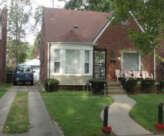
17637 Avon Avenue
Detroit, MI 48219

3BR – 1.5 BA – 1343SF
Price: $93,500
Rent $800

Taxes $2,103
17637 Avon Avenue Detroit, MI 48219

Property ID SPI594340

Click Link below for a HouseCanary Property Explorer Report :

https://pexp.housecanary.com/shared-report/17637-avon-ave/detroit/MI/48219/kOrMNZ8elA74o

Click Link below for an RealtyTrac Asset Report
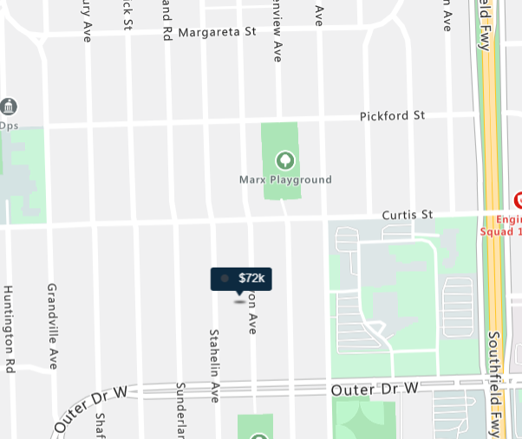
https://www.realtytrac.com/homes/mi/detroit/48219/17637-avon-ave-7567559/?preForeclosure=true&auction=true&bankOwned=true&notInForeclosure=false&notYetListed=true&listedForSale=false&recentlySold=false&listedOnlineAuction=true

For more information about the asset contact Marketing@REI-ReferralNetwork.com or call 207-443-3314

